Module 1
Assessment Questions:

1. In which OSI layer does the Wi-Fi standard/protocol fit?
Wi-Fi operates in the lower layers of the OSI (Open Systems Interconnection) model, specifically in Layer 1 (Physical Layer) and Layer 2 (Data Link Layer).

Layer 1 - Physical Layer
The Physical Layer is responsible for the actual transmission of data over the air using radio signals.
- Wi-Fi uses radio frequencies such as 2.4 GHz, 5 GHz, and 6 GHz
- It defines how bits are converted into signals and transmitted
- It includes modulation techniques like OFDM (Orthogonal Frequency Division Multiplexing)
- It handles signal strength, frequency channels, and data rates
Example: When you connect your phone to Wi-Fi, the signals traveling between your phone and router happen at the Physical Layer.

Layer 2 - Data Link Layer
The Data Link Layer ensures reliable data transfer between devices.
It has two sublayers:
- MAC (Media Access Control) Layer
- Handles device addressing using MAC addresses
- Controls how devices access the wireless medium using CSMA/CA (Collision Avoidance)
- Manages frame transmission and retransmission
- LLC (Logical Link Control) Layer
- Provides error detection and flow control
- Ensures proper communication between devices
Example: When multiple devices (laptop, mobile, TV) are connected to the same Wi-Fi, this layer ensures they communicate without collision.

Standards Used
Wi-Fi is based on standards developed by IEEE under the 802.11 family.
These standards define:
- Frequency bands
- Data rates
- Transmission techniques
- Security mechanisms

Conclusion
Wi-Fi mainly operates in:
- Layer 1 (Physical Layer) - Signal transmission
- Layer 2 (Data Link Layer) - Data framing and communication control

2. Wi-Fi devices used in daily life and their wireless capabilities
In daily life, we use multiple Wi-Fi-enabled devices. Each device supports a specific Wi-Fi standard (generation), which determines its speed, frequency, and performance.

Common Wi-Fi Devices
- Smartphones
- Laptops
- Smart TVs
- Tablets
- IoT devices (smart speakers, cameras)

Wi-Fi Generations and Standards
Wi-Fi technology has evolved through different generations:
Generation | Standard | Frequency | Speed | Features
Wi-Fi 4 | 802.11n | 2.4/5 GHz | Up to 600 Mbps | MIMO support
Wi-Fi 5 | 802.11ac | 5 GHz | Up to 3.5 Gbps | Faster speed, beamforming
Wi-Fi 6 | 802.11ax | 2.4/5 GHz | Up to 9.6 Gbps | OFDMA, better efficiency
These standards are defined by IEEE and certified by Wi-Fi Alliance.

Example Mapping of Devices

1. Smartphone
- Modern phones support Wi-Fi 5 or Wi-Fi 6
- Properties:
  - Dual-band (2.4 GHz & 5 GHz)
  - High speed
  - Better battery efficiency

2. Laptop
- Usually supports Wi-Fi 5 or Wi-Fi 6
- Properties:
  - Higher bandwidth usage
  - Stable connection
  - Supports advanced features like MU-MIMO

3. Smart TV
- Mostly supports Wi-Fi 4 or Wi-Fi 5
- Properties:
  - Used for streaming
  - Requires stable connection more than high speed

4. IoT Devices (e.g., Alexa, CCTV)
- Mostly use Wi-Fi 4 (802.11n)
- Properties:
  - Operate on 2.4 GHz
  - Low power consumption
  - Lower data requirements

How to Check Device Capability In Real Time (Practical)
We can check your device’s Wi-Fi properties by:
- Opening Wi-Fi settings
- Viewing connection details
- Checking:
  - Frequency band (2.4 GHz / 5 GHz)
  - Link speed (Mbps)
  - Protocol (802.11n/ac/ax)

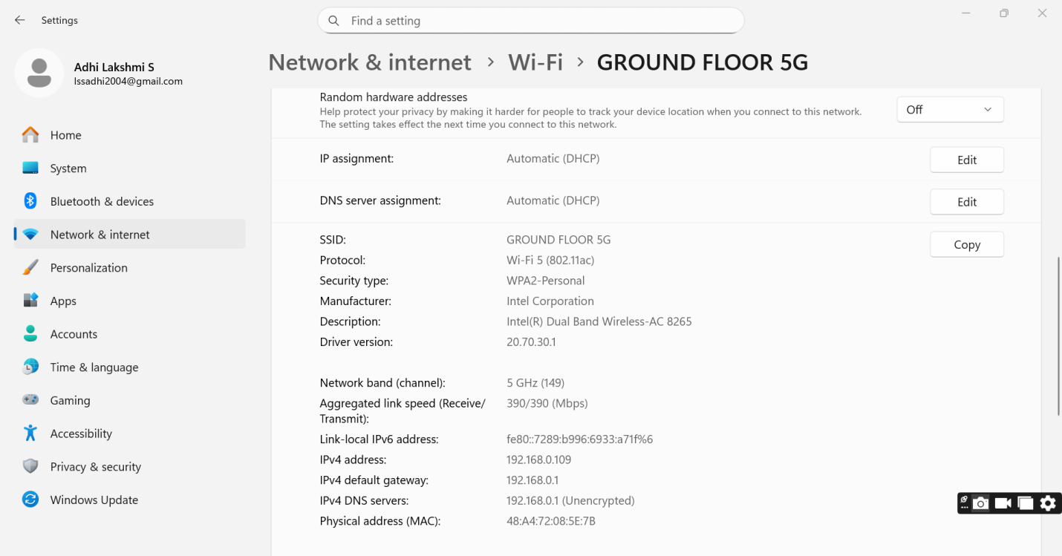

Conclusion
Different devices support different Wi-Fi generations based on:
- Usage (streaming, browsing, IoT)
- Speed requirements
- Power consumption
Modern devices use newer standards for better speed and efficiency, while older or IoT devices use simpler standards for stability and low power usage.

3. What is BSS and ESS?
In Wi-Fi networking, BSS (Basic Service Set) and ESS (Extended Service Set) are fundamental concepts that describe how wireless networks are organized.

Basic Service Set (BSS)
A BSS is the smallest unit of a Wi-Fi network, consisting of:
- One Access Point (AP)
- Multiple wireless devices (stations)
All devices communicate through the AP.

Key Features:
- Uses a single AP
- Has a unique identifier called BSSID (MAC address of AP)
- Covers a limited geographical area
- All communication is centralized via the AP

Example:
A home Wi-Fi network where:
- One router provides internet
- Devices like phone, laptop, and TV connect to it
This is a Single BSS network

Types of BSS
- Infrastructure BSS
  - Uses an Access Point
  - Most common type
  - Example: Home, office Wi-Fi
- Independent BSS (IBSS)
  - No Access Point
  - Device-to-device communication (Ad-hoc mode)

Extended Service Set (ESS)
An ESS is formed by connecting multiple BSS networks together.
- Multiple Access Points are connected through a wired network (like LAN)
- All APs share the same SSID (Wi-Fi name)
- Allows seamless roaming

Key Features:
- Large coverage area
- Multiple APs
- Same network name (SSID)
- Supports mobility (roaming)

Example:
College or office Wi-Fi:
- Multiple routers in different areas
- Same Wi-Fi name
- User moves without disconnecting

Difference between BSS and ESS
Feature | BSS | ESS
Number of APs | One | Multiple
Coverage | Small | Large
Roaming | Not supported | Supported
Example | Home Wi-Fi | Campus Wi-Fi

Conclusion
- BSS = Single Wi-Fi network (one AP)
- ESS = Multiple connected Wi-Fi networks (many APs, same SSID)

4. What are the basic functionalities of a Wi-Fi Access Point?
A Wi-Fi Access Point (AP) is a networking device that allows wireless devices to connect to a wired network.
It acts as a bridge between wireless clients and the internet.

Main Functionalities of a Wi-Fi Access Point

1. SSID Broadcasting
- AP broadcasts the network name (SSID)
- Allows devices to discover and connect
Example: “Home_WiFi”, “College_Network”

2. Authentication and Security
- Verifies user identity before allowing access
- Supports security protocols like:
  - WPA2
  - WPA3

3. Data Transmission
- Transfers data between:
  - Wireless devices ↔ Access Point
  - Access Point ↔ Wired network

4. Medium Access Control (MAC Function)
- Controls how multiple devices use the wireless medium
- Uses CSMA/CA (Collision Avoidance)
Ensures no data collision happens

5. Signal Management
- Manages signal strength and coverage
- Adjusts transmission power
- Provides stable connectivity

6. Traffic Management
- Controls data flow between devices
- Prioritizes important traffic (QoS – Quality of Service)
Example: Video call gets priority over downloads

7. Roaming Support
- Helps devices switch between APs without disconnecting
- Used in ESS networks

8. Network Bridging
- Connects wireless network to wired LAN
- Acts as a bridge between two different network types

Conclusion
A Wi-Fi Access Point performs multiple roles:
- Connects devices wirelessly
- Ensures secure communication
- Manages traffic and signals
- Provides seamless connectivity

5. Difference between Bridge Mode and Repeater Mode
In Wi-Fi networking, Bridge Mode and Repeater Mode are used to extend or connect networks, but they function differently.

Bridge Mode
Bridge mode is used to connect two separate networks and make them act as a single network.

Key Features:
- Connects two LANs (wired or wireless)
- Works like a “bridge” between networks
- Does not create a new network
- Maintains original network performance
- Can use wired or wireless connection

How it Works:
- One router connects to another router
- The second router passes data without modifying it

Example:
- Connecting two buildings using wireless bridge
- Extending office network using Ethernet cable

Repeater Mode
Repeater mode is used to extend the range of an existing Wi-Fi network.

Key Features:
- Receives signal and retransmits it
- Extends Wi-Fi coverage
- Works wirelessly
- Reduces speed due to signal repetition

How it Works:
- Repeater connects to main router
- Rebroadcasts the same Wi-Fi signal to farther areas

Example:
- Extending home Wi-Fi to another room or floor

Difference between Bridge Mode and Repeater Mode
Feature | Bridge Mode | Repeater Mode
Purpose | Connect two networks | Extend Wi-Fi coverage
Connection Type | Wired/Wireless | Wireless only
Speed | High (no loss) | Reduced (signal duplication)
Network Creation | No new network | Extends existing network
Usage | Offices, buildings | Homes, small areas

Conclusion
- Bridge Mode is used for connecting networks without affecting speed
- Repeater Mode is used for increasing coverage but may reduce speed

6. Differences between 802.11a and 802.11b
The standards 802.11a and 802.11b are early Wi-Fi technologies defined by IEEE under the 802.11 family.

802.11a

Key Features:
- Operates in 5 GHz frequency band
- Maximum speed up to 54 Mbps
- Uses OFDM modulation
- Less interference (fewer devices use 5 GHz)
- Shorter range

Advantages:
- Faster speed
- Less congestion

Disadvantages:
- Lower coverage area
- Higher cost (earlier days)

802.11b

Key Features:
- Operates in 2.4 GHz frequency band
- Maximum speed up to 11 Mbps
- Uses DSSS (Direct Sequence Spread Spectrum)
- More interference (used by many devices)
- Longer range

Advantages:
- Better coverage
- Lower cost

Disadvantages:
- Slower speed
- More interference

Comparison Table
Feature | 802.11a | 802.11b
Frequency | 5 GHz | 2.4 GHz
Maximum Speed | 54 Mbps | 11 Mbps
Range | Shorter | Longer
Interference | Less | More
Cost | Higher | Lower

Conclusion
- 802.11a - Faster, less interference, shorter range
- 802.11b - Slower, more interference, longer range

7. Configure your modem/hotspot to operate only in 2.4 GHz and 5 GHz, and compare the properties
This question involves a practical experiment where you test and compare Wi-Fi performance in 2.4 GHz and 5 GHz bands.

Step 1: Configure 2.4 GHz Network
- Open mobile hotspot or router settings
- Select Wi-Fi band → 2.4 GHz only
- Turn ON hotspot/router
- Connect your laptop or mobile device
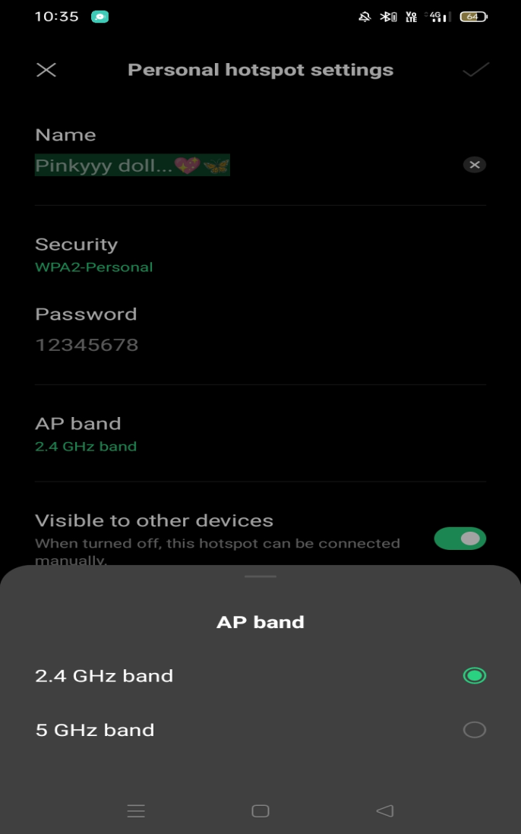

Step 2: Note the Properties
Check Wi-Fi details in your device:
- Frequency band (2.4 GHz)
- Link speed (Mbps)
- Signal strength
- Network stability
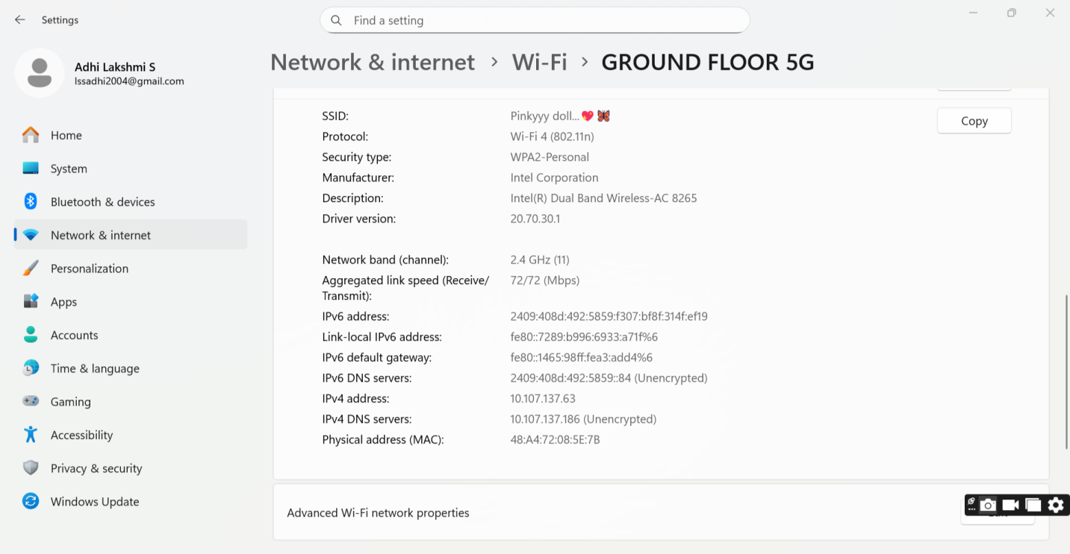

Step 3: Configure 5 GHz Network
- Change hotspot/router band to 5 GHz only
- Reconnect your device
- Observe the same parameters
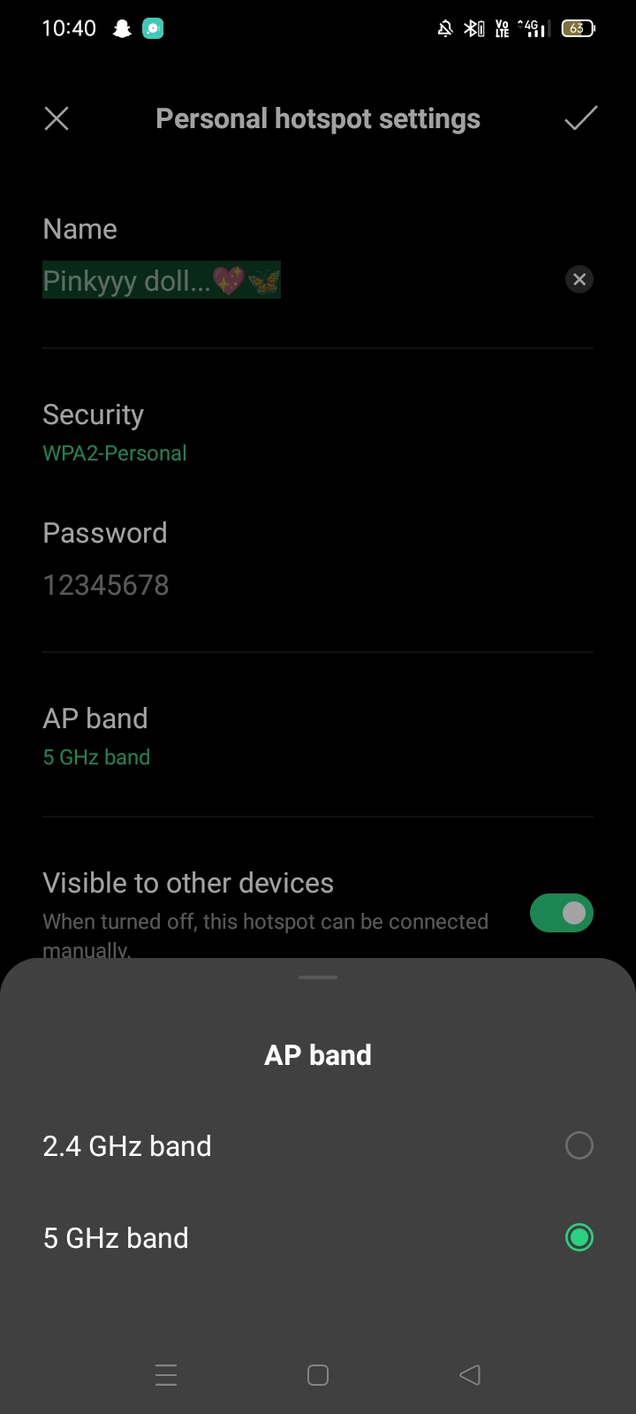

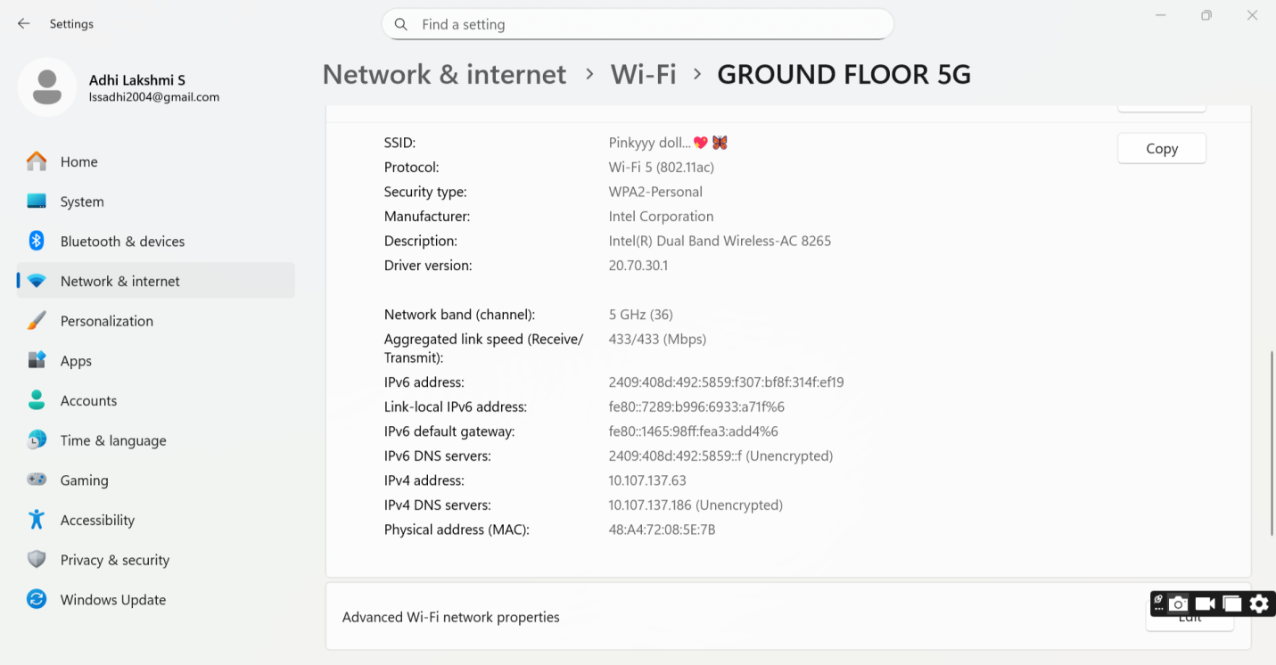

Observations
Parameter | 2.4 GHz | 5 GHz
Frequency | 2.4 GHz | 5 GHz
Speed | Lower | Higher
Range | Longer | Shorter
Wall Penetration | Better | Poor
Interference | High (many devices) | Low
Stability | Moderate | High (near router)

Explanation
- 2.4 GHz travels farther and passes through walls easily but suffers from interference (Bluetooth, microwave, etc.)
- 5 GHz provides higher speed and less interference but works best at shorter distances

Conclusion
- Use 2.4 GHz for larger coverage areas
- Use 5 GHz for high-speed internet in shorter range

8. What is the difference between IEEE and Wi-Fi Alliance?
Wi-Fi technology is governed and standardized by two main organizations:
- IEEE
- Wi-Fi Alliance

IEEE (Institute of Electrical and Electronics Engineers)

Role:
- Develops technical standards for Wi-Fi
- Defines the 802.11 protocols

Responsibilities:
- Specifies frequency bands, data rates, and modulation techniques
- Creates standards like:
  - 802.11a
  - 802.11b
  - 802.11n
  - 802.11ac
  - 802.11ax
It focuses on how Wi-Fi should work technically

Wi-Fi Alliance (WFA)

Role:
- Certifies Wi-Fi devices for compatibility

Responsibilities:
- Tests devices from different companies
- Ensures devices work together properly
- Provides branding like:
  - Wi-Fi 4
  - Wi-Fi 5
  - Wi-Fi 6
It focuses on making sure devices work together in real life

Difference between IEEE and Wi-Fi Alliance
Feature | IEEE | Wi-Fi Alliance
Type | Technical organization | Industry organization
Role | Creates standards | Certifies devices
Focus | Protocol design | Compatibility & branding
Example | 802.11ax | Wi-Fi 6 certification

Conclusion
- IEEE develops the technical foundation of Wi-Fi
- Wi-Fi Alliance ensures devices follow those standards and work together smoothly

9. What are the different types of Wi-Fi backhaul?
Backhaul refers to the connection that links a Wi-Fi network (like a router or access point) to the main internet source.
In simple terms, it is the path through which internet data reaches your Wi-Fi network.

Types of Wi-Fi Backhaul

1. Wired Backhaul (Ethernet)
- Uses Ethernet cables to connect routers or access points
- Most reliable and stable connection
- Provides high speed with minimal latency

Advantages:
- No signal interference
- High performance
- Stable connection

Example:
- Fiber internet - Router - Access Point using Ethernet cable

2. Wireless Backhaul
- Uses wireless signals to connect routers or mesh nodes
- No cables required
- Common in mesh Wi-Fi systems

Advantages:
- Easy to install
- Flexible placement

Disadvantages:
- Speed may reduce due to signal sharing
- Affected by interference

Example:
- Mesh Wi-Fi system in homes or offices

3. Fiber Backhaul
- Uses optical fiber cables
- Provides extremely high speed and bandwidth

Advantages:
- Very high data rates
- Low latency
- Long-distance communication

Example:
- Internet Service Providers (ISPs) use fiber to deliver internet to homes

4. DSL Backhaul
- Uses telephone lines
- Slower compared to fiber and Ethernet

Advantages:
- Widely available
- Cost-effective

Disadvantages:
- Lower speed
- Higher latency

Comparison Table
Type | Medium | Speed | Reliability
Wired (Ethernet) | Cable | High | Very High
Wireless | Air | Medium | Moderate
Fiber | Optical Cable | Very High | Very High
DSL | Telephone Line | Low | Moderate

Conclusion
- Wired and Fiber backhaul - Best performance
- Wireless backhaul - Flexible but may reduce speed
- DSL - Basic connectivity with lower speed

10. Different Wi-Fi topologies and their use cases
Wi-Fi topology refers to the structure or arrangement of devices in a wireless network.

1. Infrastructure Topology
- Most common type
- Uses an Access Point (AP)
- Devices communicate through the AP

Features:
- Centralized control
- Stable connection
- Easy management

Use Case:
- Homes
- Offices
- Schools

2. Ad-hoc Topology (Peer-to-Peer)
- No Access Point required
- Devices connect directly to each other

Features:
- Simple setup
- Temporary connection

Use Case:
- File sharing between two laptops
- Small temporary networks

3. Mesh Topology
- Multiple APs (nodes) interconnected
- Each node communicates with others

Features:
- Wide coverage
- Self-healing network
- Seamless roaming

Use Case:
- Large homes
- Campuses
- Malls

4. Point-to-Point Topology
- Direct connection between two locations

Features:
- Long-distance communication
- High-speed link

Use Case:
- Connecting two buildings
- Industrial networks

5. Point-to-Multipoint Topology
- One central AP connects multiple devices

Features:
- One-to-many communication
- Efficient for distribution

Use Case:
- Internet service distribution
- Office networks

Comparison Table
Topology | Description | Use Case
Infrastructure | AP-based network | Home, office
Ad-hoc | Device-to-device | Temporary sharing
Mesh | Multiple interconnected APs | Large areas
Point-to-Point | Two-node connection | Building links
Point-to-Multipoint | One-to-many connection | ISPs, offices

Conclusion
- Different topologies are used based on network size and requirement
- Infrastructure is most common
- Mesh is best for large coverage
- Ad-hoc is useful for temporary connections

